*R - ASSIGNMENT CODES*

**1. Explore the relationship between the following, where x contains numbers from 1 to 100.**

**a. x and x^2**

**Sol:**  **x<- c(1:100)**

**y <- x^2**

**plot(x,y)**

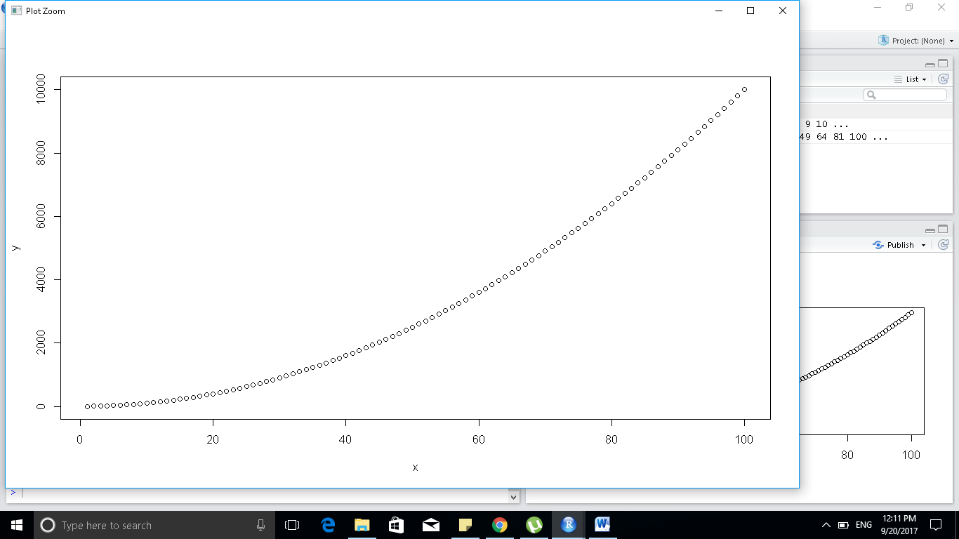

**b. x and x^3**

**sol: x<- c(1:100)**

**y <- x^3**

**plot(x,y)**

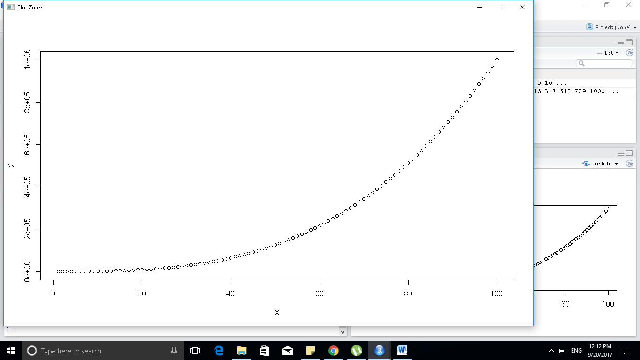

**2. Produce simple graph using the values in the car vector:**

**#define the cars vector with 5 values cars<-c(1,3,6,4,9)**

**Sol : cars <- c(1,3,6,4,9)**

**# Graph the cars vector with all defaults plots(cars)**

**Sol: plot(cars)**

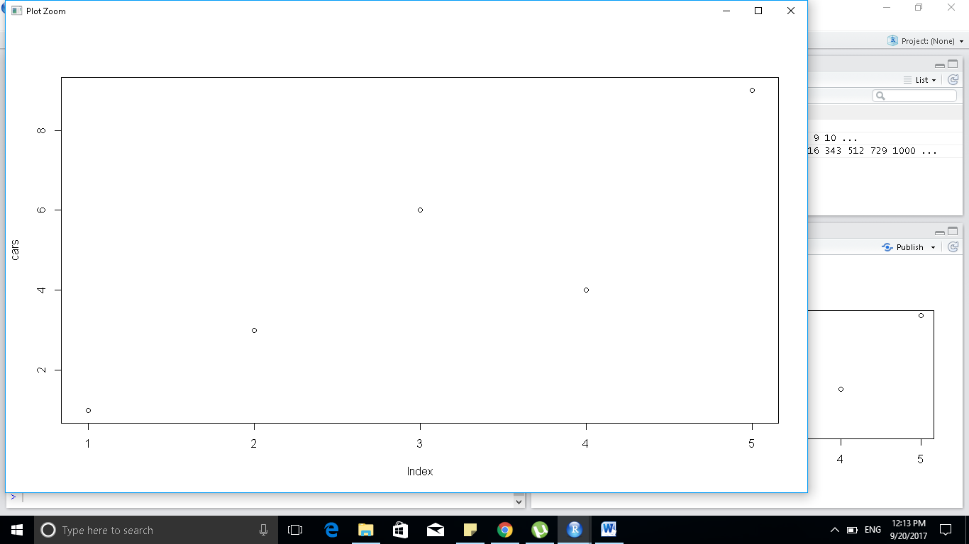

**# Define the cars vector with 5 values cars <- c(1, 3, 6, 4, 9)**

**Sol: cars <- c(1,3,6,4,9)**

**# Graph cars using blue points overlayed by a line plot(cars, type="o", col="blue")**

**Sol: plot(cars,type="o",col="blue")**

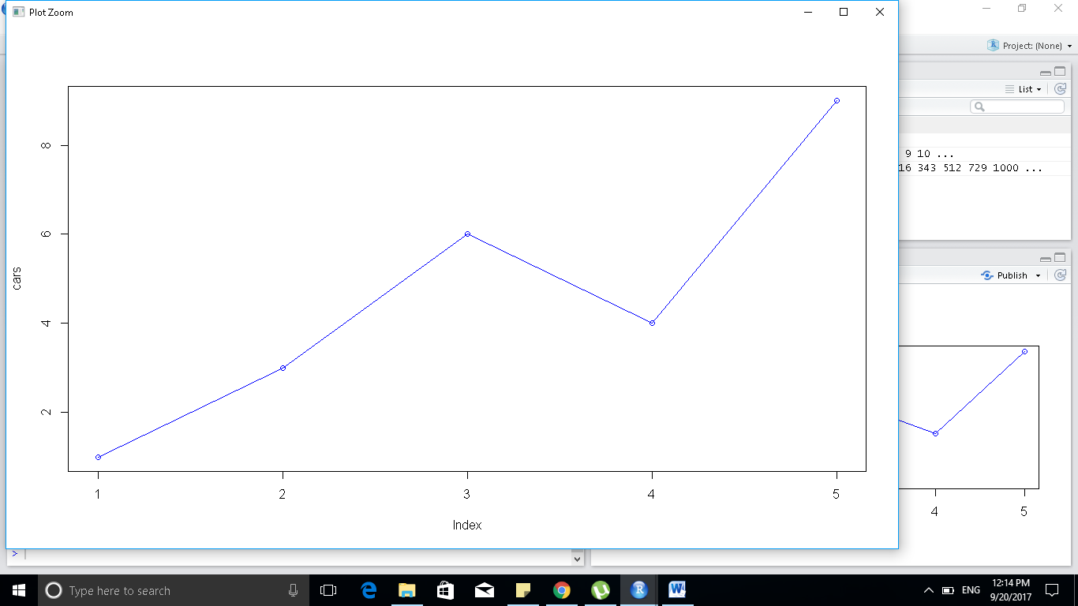

**#Create a title with a red, bold/italic font title(main="Autos", col.main="red", font.main=4)**

**Sol: title(main="Autos", col.main="red", font.main=4)**

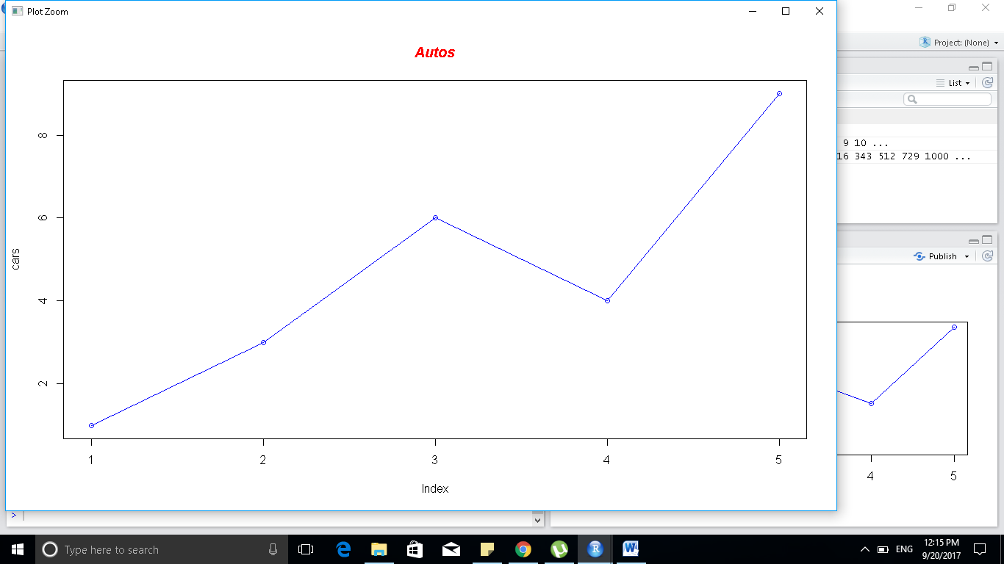

**2. # Define 2 vectors cars <- c(1, 3, 6, 4, 9) trucks <- c(2, 5, 4, 5, 12)**

**Sol:**

**cars <- c(1,3,6,4,9)**

**trucks <- c(2, 5, 4, 5, 12)**

**# Graph cars using a y axis that ranges from 0 to 12 plot(cars, type="o", col="blue",**

**#ylim=c(0,12)**

**Sol**

**plot(cars, type="o", col="blue", ylim=c(0,12))**

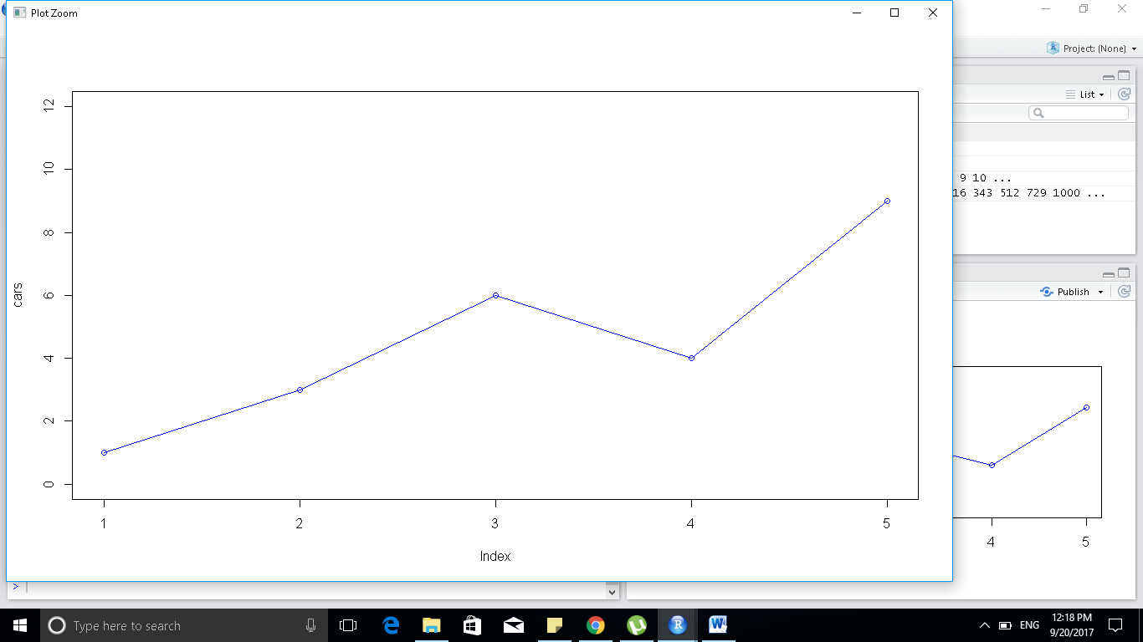

**# Graph trucks with red dashed line and square points lines(trucks, type="o", pch=22,**

**#lty=2, col="red")**

**Sol: lines(trucks, type="o", pch=22,lty=2, col="red")**

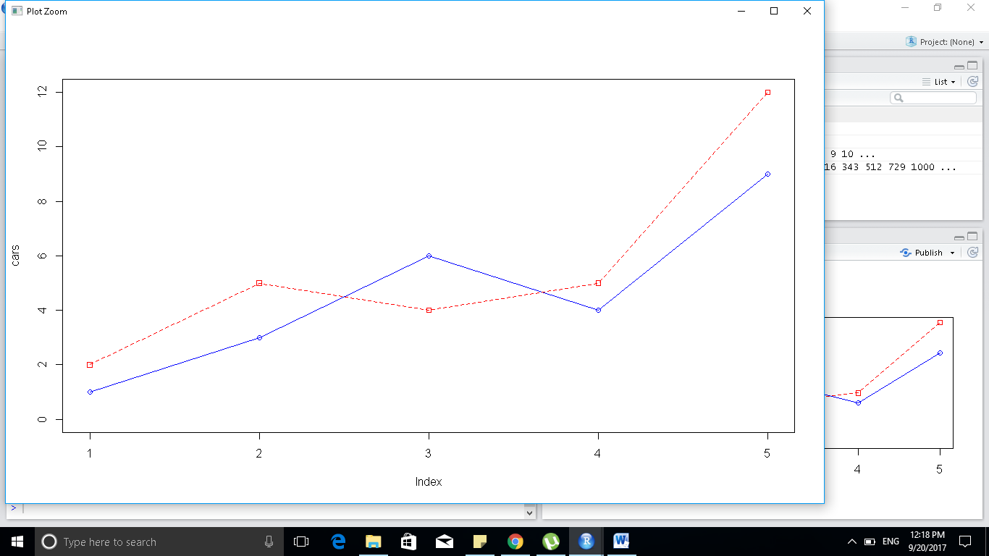

**# Create a title with a red, bold/italic font title(main="Autos", col.main="red",**

**font.main=4)**

**Sol: title(main="Autos", col.main="red",font.main=4)**

